Cylinder-Based Repeated Composite Solids

Definition
# Source: AI Source: Provided by: [Data Path: Persons Table -> ID Column: 1, Name_En Column: Motasem Essam] -> From: [ChatGPT] on [7/25/2026]
Cylinder-Based Repeated Composite Solids are three-dimensional geometric structures formed by joining two or more cylinders in a repeated pattern or arrangement.
The cylinders may have identical or different radii, heights, and orientations. They can be connected through their circular bases, arranged along a common axis, stacked, positioned side-by-side, or combined into more complex three-dimensional structures.
These composite solids include coaxial cylindrical structures, stacked cylinders, stepped cylindrical forms, radial arrangements, hollow cylindrical structures, and other repeated configurations.

Simple Definition
# Source: AI Source: Provided by: [Data Path: Persons Table -> ID Column: 1, Name_En Column: Motasem Essam] -> From: [ChatGPT] on [7/25/2026]
A cylinder-based repeated composite solid is a 3D structure made by joining multiple cylinders in a repeated arrangement.
For example, several identical cylinders stacked vertically or connected end-to-end form cylinder-based repeated composite solids.

Geometric Representation
# Source: AI Source: Provided by: [Data Path: Persons Table -> ID Column: 1, Name_En Column: Motasem Essam] -> From: [ChatGPT] on [7/25/2026]
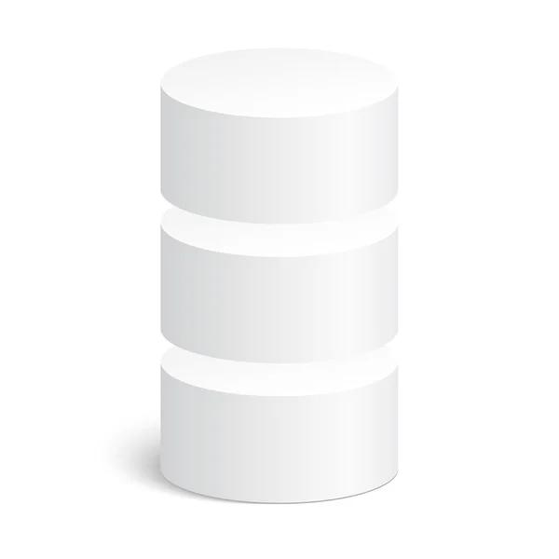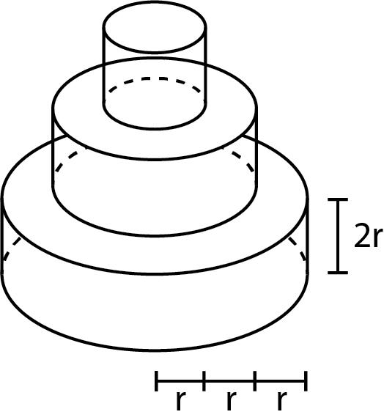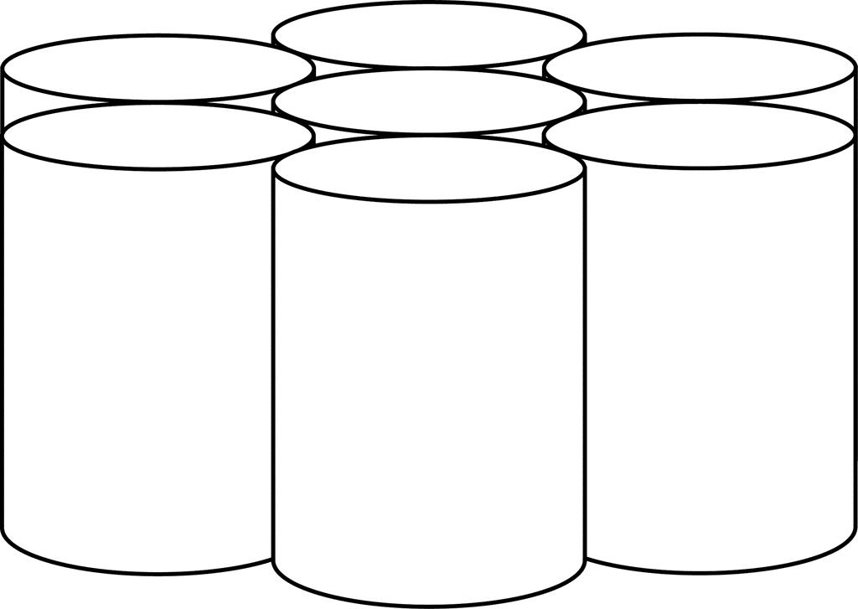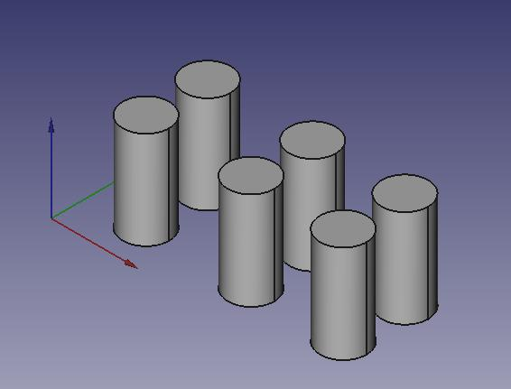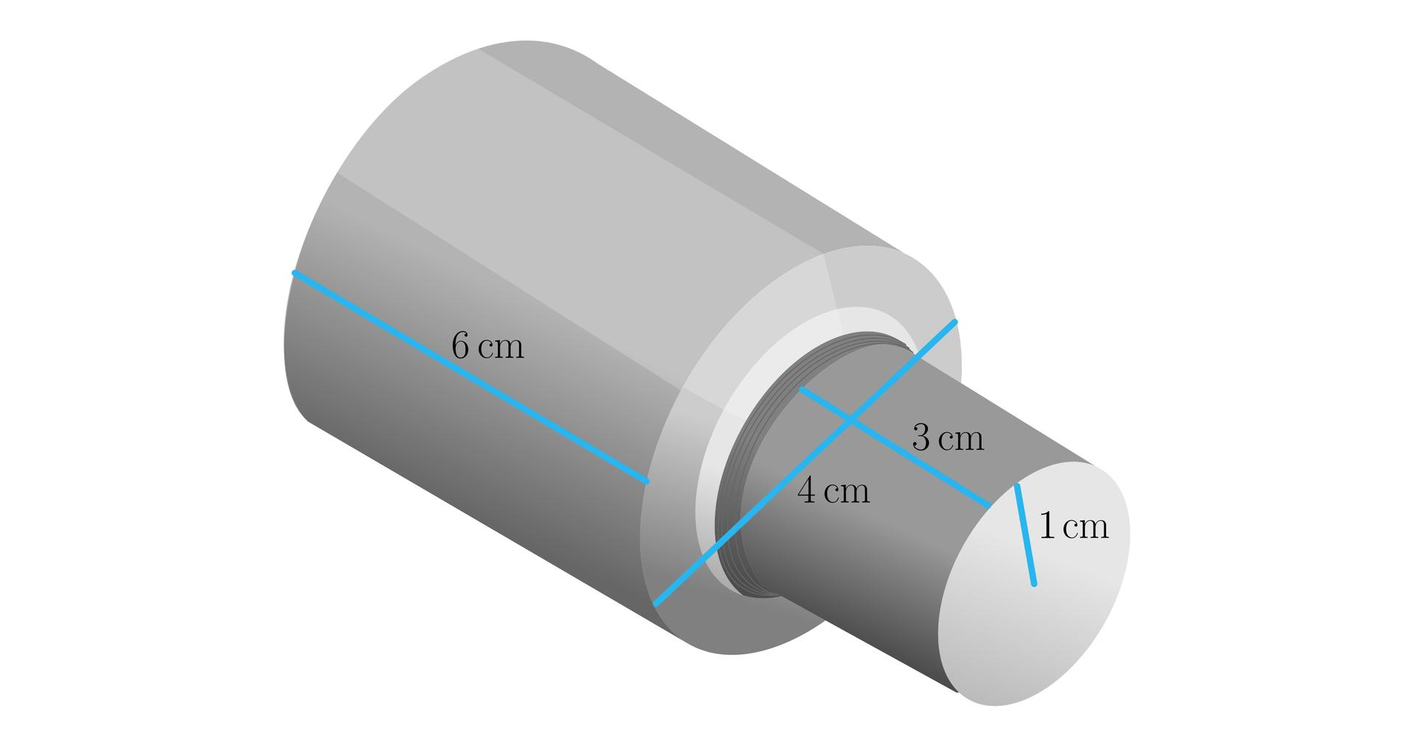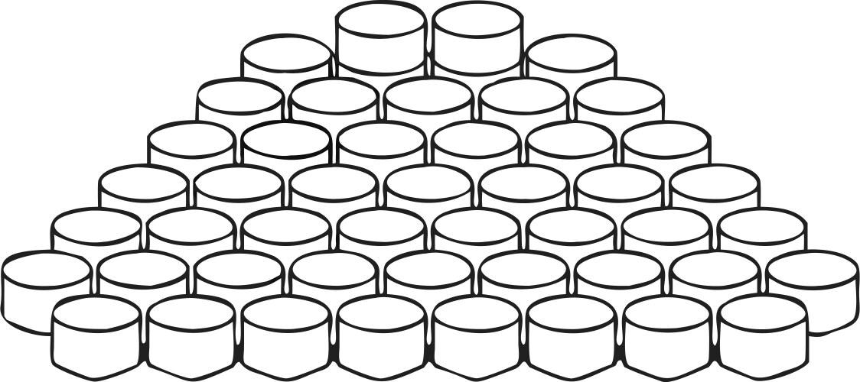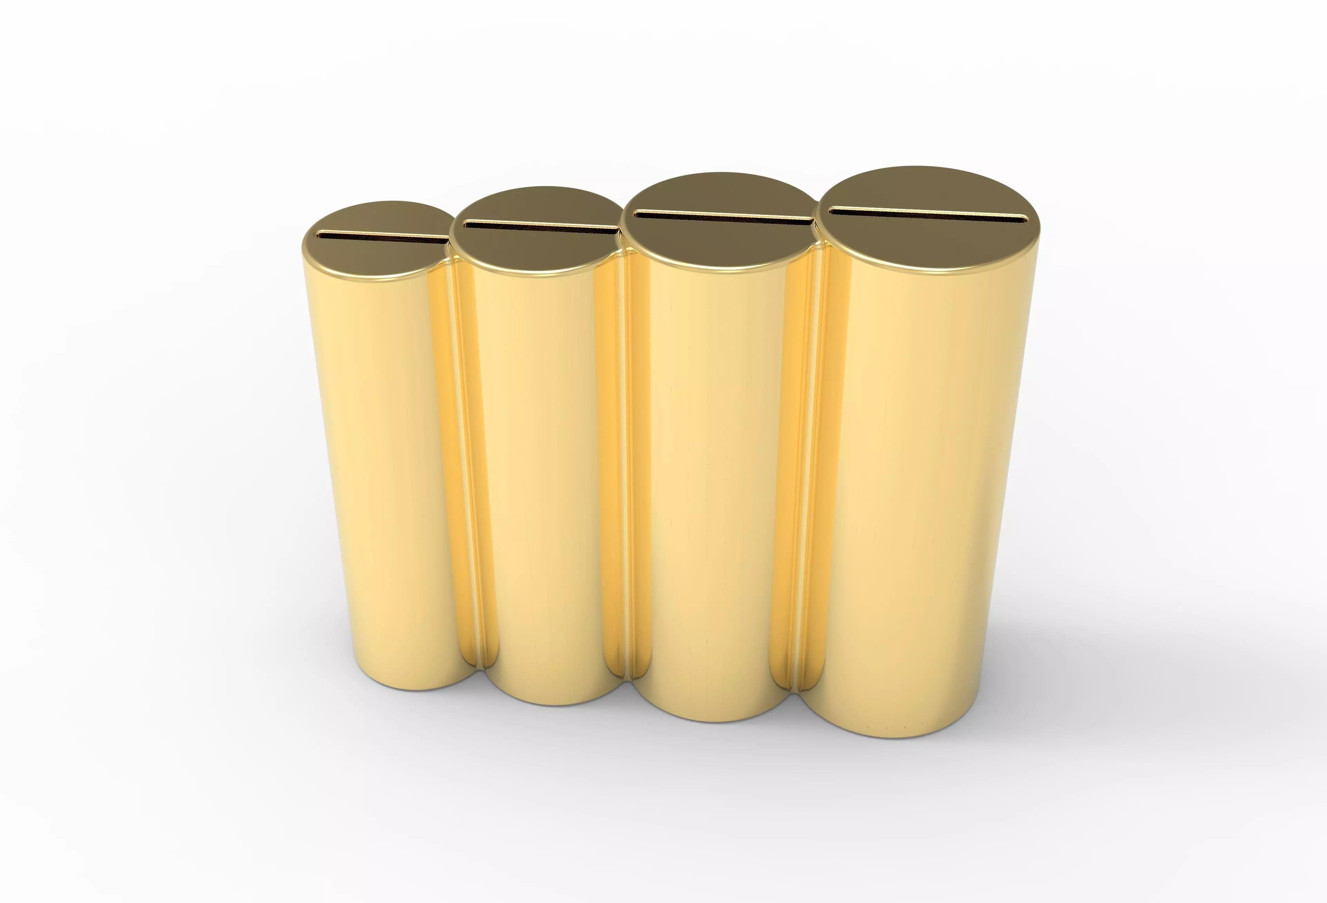
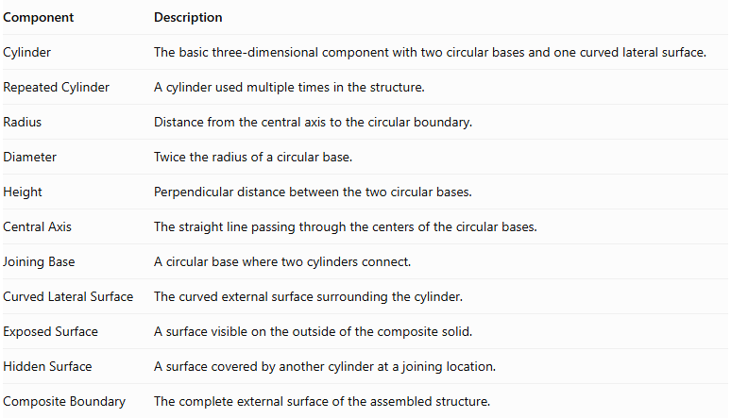
Component | Description
Cylinder | The basic three-dimensional component with two circular bases and one curved lateral surface.
Repeated Cylinder | A cylinder used multiple times in the structure.
Radius | Distance from the central axis to the circular boundary.
Diameter | Twice the radius of a circular base.
Height | Perpendicular distance between the two circular bases.
Central Axis | The straight line passing through the centers of the circular bases.
Joining Base | A circular base where two cylinders connect.
Curved Lateral Surface | The curved external surface surrounding the cylinder.
Exposed Surface | A surface visible on the outside of the composite solid.
Hidden Surface | A surface covered by another cylinder at a joining location.
Composite Boundary | The complete external surface of the assembled structure.

Types of Cylinder-Based Repeated Composite Solids

Linear Cylinder-Based Composite Solids
# Source: AI Source: Provided by: [Data Path: Persons Table -> ID Column: 1, Name_En Column: Motasem Essam] -> From: [ChatGPT] on [7/25/2026]
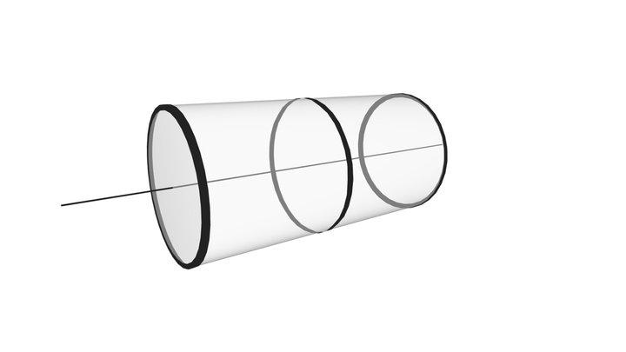
Formed by joining cylinders in a straight sequence along one direction.
Types include:
- Horizontal Linear Arrangement.
- Vertical Linear Arrangement.
- Depth-Wise Linear Arrangement.
- Alternating Linear Arrangement.
- Equal-Dimension Linear Arrangement.
- Different-Dimension Linear Arrangement.

Coaxial Cylinder-Based Composite Solids
# Source: AI Source: Provided by: [Data Path: Persons Table -> ID Column: 1, Name_En Column: Motasem Essam] -> From: [ChatGPT] on [7/25/2026]
Formed by arranging two or more cylinders along the same central axis.
Types include:
- Equal-Radius Coaxial Arrangement.
- Different-Radius Coaxial Arrangement.
- Equal-Height Coaxial Arrangement.
- Different-Height Coaxial Arrangement.
- Progressively Enlarged Coaxial Arrangement.
- Progressively Reduced Coaxial Arrangement.

Stacked Cylinder-Based Composite Solids
# Source: AI Source: Provided by: [Data Path: Persons Table -> ID Column: 1, Name_En Column: Motasem Essam] -> From: [ChatGPT] on [7/25/2026]

Formed by placing cylinders on top of one another, usually through their circular bases.
Types include:
- Equal-Size Stacked Cylinders.
- Different-Size Stacked Cylinders.
- Progressively Enlarged Stack.
- Progressively Reduced Stack.
- Alternating-Size Stack.
- Multi-Level Cylindrical Stack.

Stepped Cylinder-Based Composite Solids
# Source: AI Source: Provided by: [Data Path: Persons Table -> ID Column: 1, Name_En Column: Motasem Essam] -> From: [ChatGPT] on [7/25/2026]
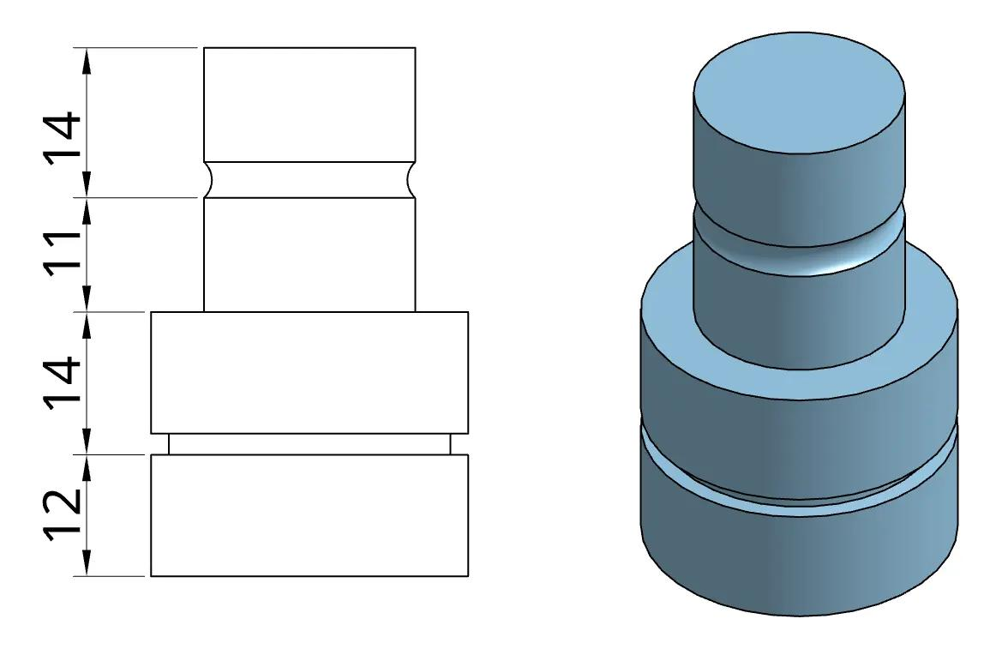
Formed by connecting cylinders of different radii or heights to create a stepped external profile.
Types include:
- Ascending Stepped Arrangement.
- Descending Stepped Arrangement.
- Symmetrical Stepped Arrangement.
- Asymmetrical Stepped Arrangement.
- Multi-Level Stepped Arrangement.
- Alternating-Radius Stepped Arrangement.

Side-by-Side Cylinder-Based Composite Solids
# Source: AI Source: Provided by: [Data Path: Persons Table -> ID Column: 1, Name_En Column: Motasem Essam] -> From: [ChatGPT] on [7/25/2026]
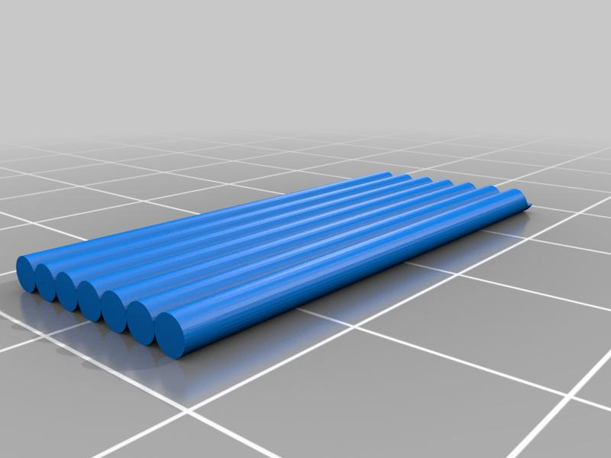
Formed by positioning multiple cylinders next to one another, usually with parallel central axes.
Types include:
- Two-Cylinder Side-by-Side Arrangement.
- Row-Based Arrangement.
- Grid-Based Arrangement.
- Parallel Cylinder Arrangement.
- Equal-Spacing Arrangement.
- Unequal-Spacing Arrangement.
Note: Cylinders placed side-by-side may touch along curved surfaces. The actual contact region must be considered when calculating the external surface area.

Radial Cylinder-Based Composite Solids
# Source: AI Source: Provided by: [Data Path: Persons Table -> ID Column: 1, Name_En Column: Motasem Essam] -> From: [ChatGPT] on [7/25/2026]
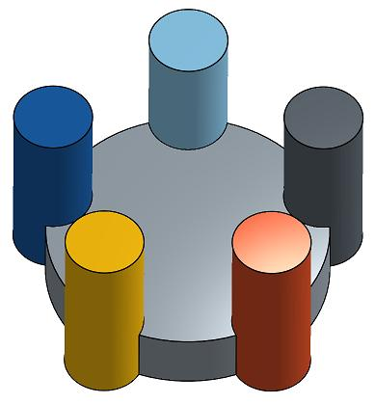
Formed by arranging cylinders around a central region or central cylinder.
Types include:
- Two-Direction Radial Arrangement.
- Three-Cylinder Radial Arrangement.
- Four-Cylinder Radial Arrangement.
- Circular Radial Arrangement.
- Symmetrical Radial Arrangement.
- Multi-Layer Radial Arrangement.

Cross-Shaped Cylinder-Based Composite Solids
# Source: AI Source: Provided by: [Data Path: Persons Table -> ID Column: 1, Name_En Column: Motasem Essam] -> From: [ChatGPT] on [7/25/2026]
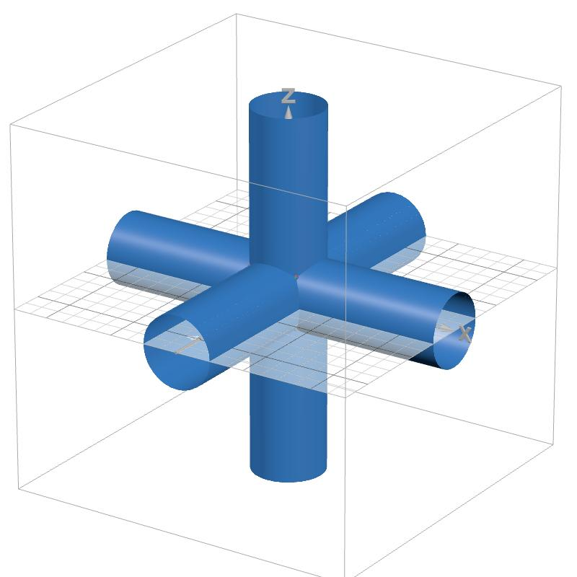
Formed by connecting cylinders along two or more intersecting directions.
Types include:
- Two-Direction Cross Arrangement.
- Three-Direction Cross Arrangement.
- Four-Arm Cross Arrangement.
- Multi-Arm Cross Arrangement.
- Symmetrical Cross Arrangement.
- Asymmetrical Cross Arrangement.

Branching Cylinder-Based Composite Solids
# Source: AI Source: Provided by: [Data Path: Persons Table -> ID Column: 1, Name_En Column: Motasem Essam] -> From: [ChatGPT] on [7/25/2026]
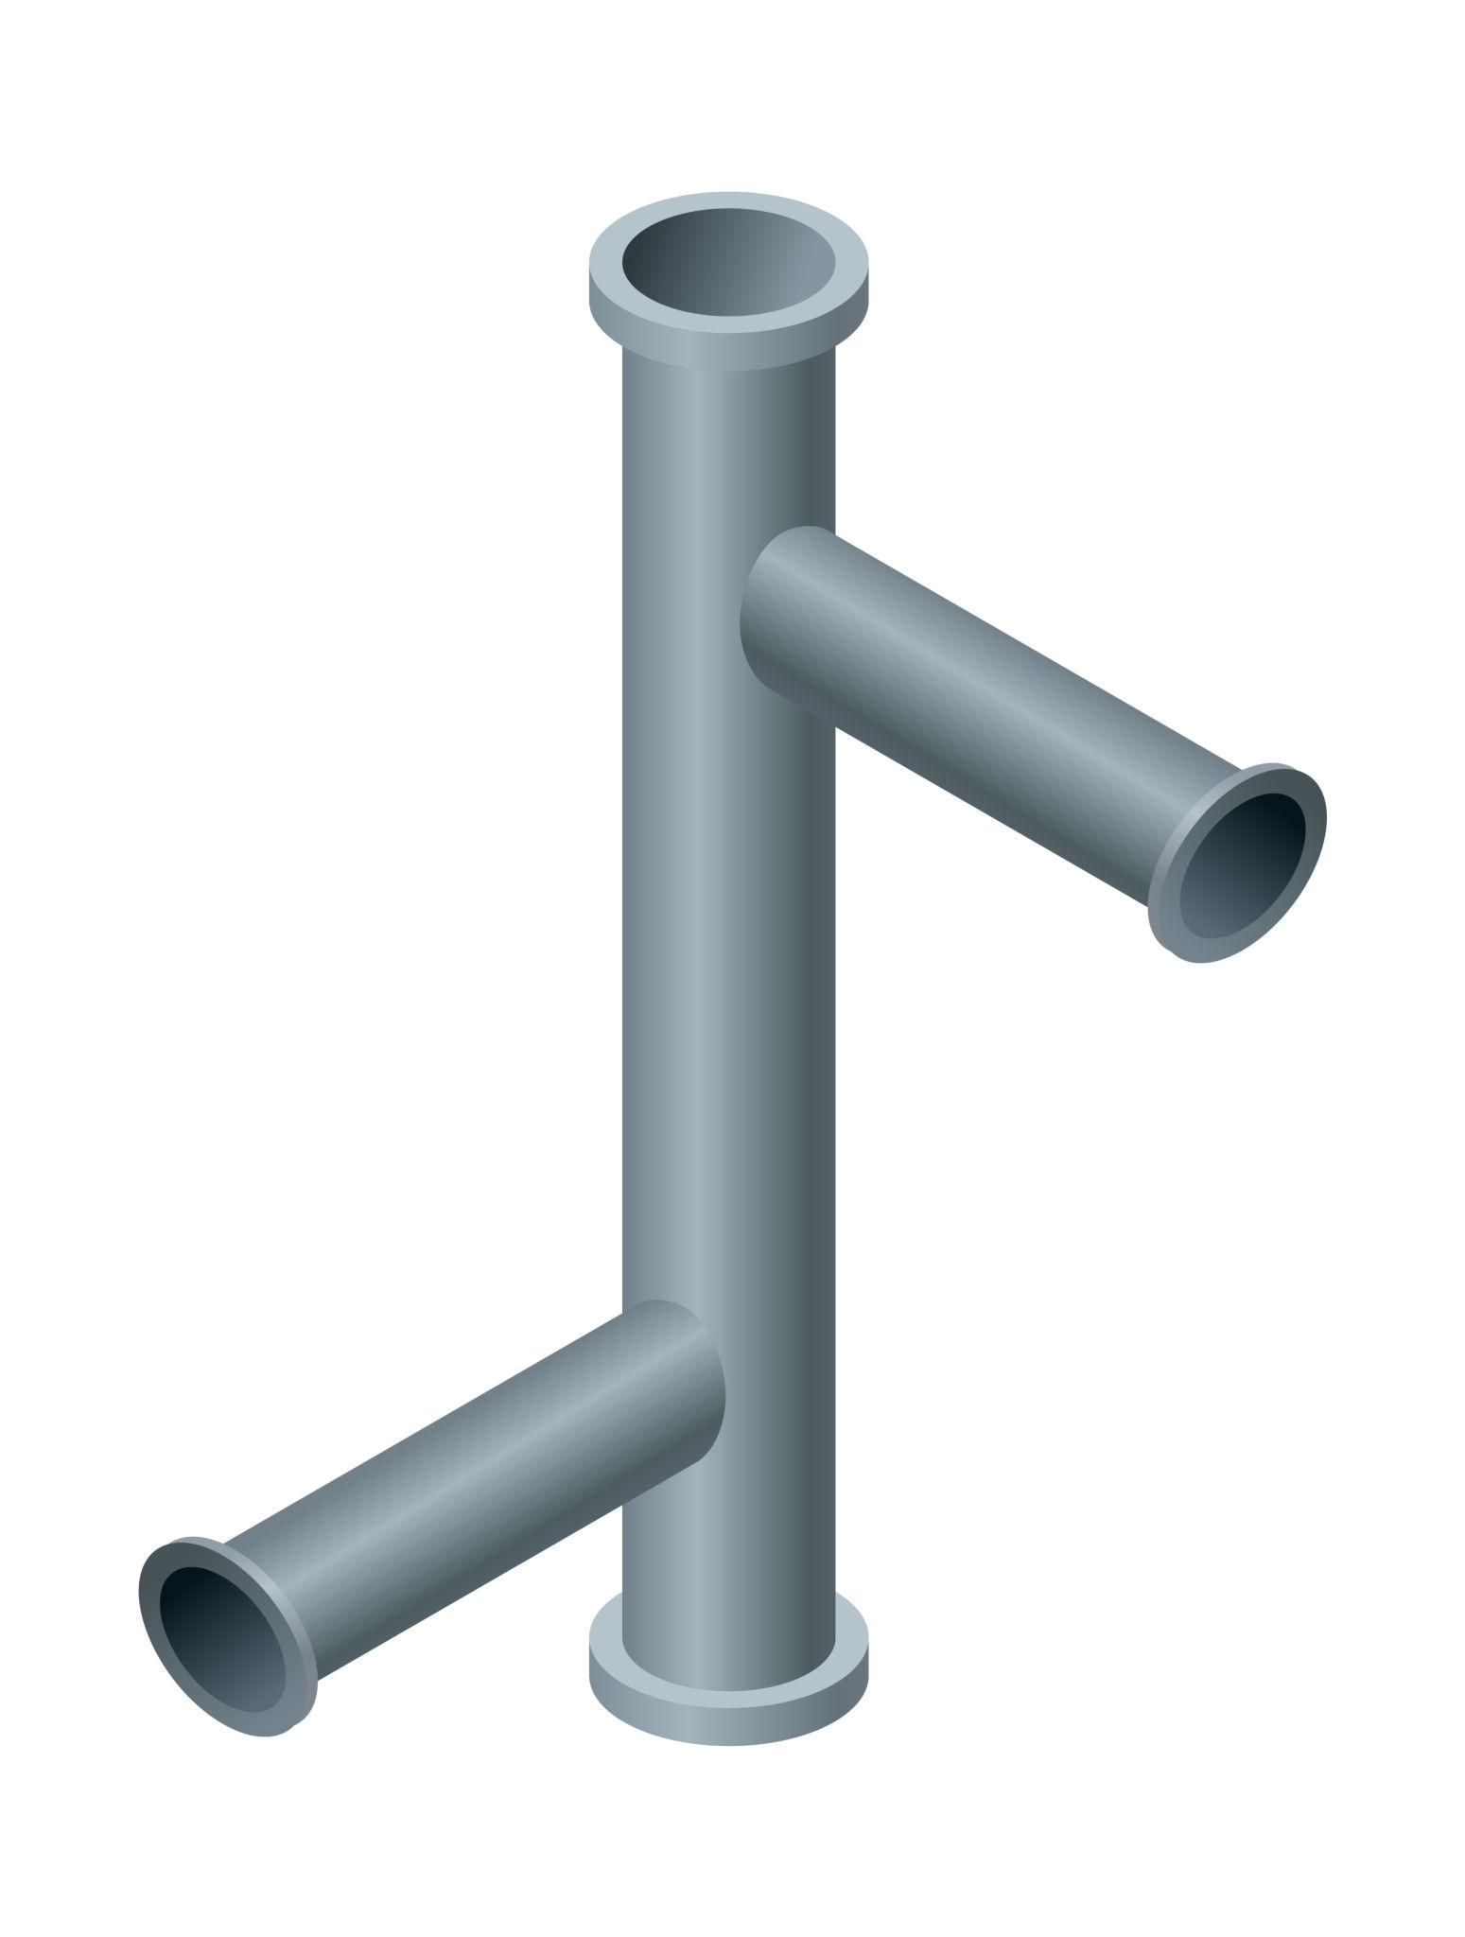
Formed by connecting cylindrical components to a main cylinder through one or more branches.
Types include:
- Single-Branch Arrangement.
- Double-Branch Arrangement.
- Multiple-Branch Arrangement.
- T-Junction Arrangement.
- Y-Junction Arrangement.
- Multi-Level Branching Arrangement.

Hollow Cylinder-Based Repeated Composite Solids
# Source: AI Source: Provided by: [Data Path: Persons Table -> ID Column: 1, Name_En Column: Motasem Essam] -> From: [ChatGPT] on [7/25/2026]
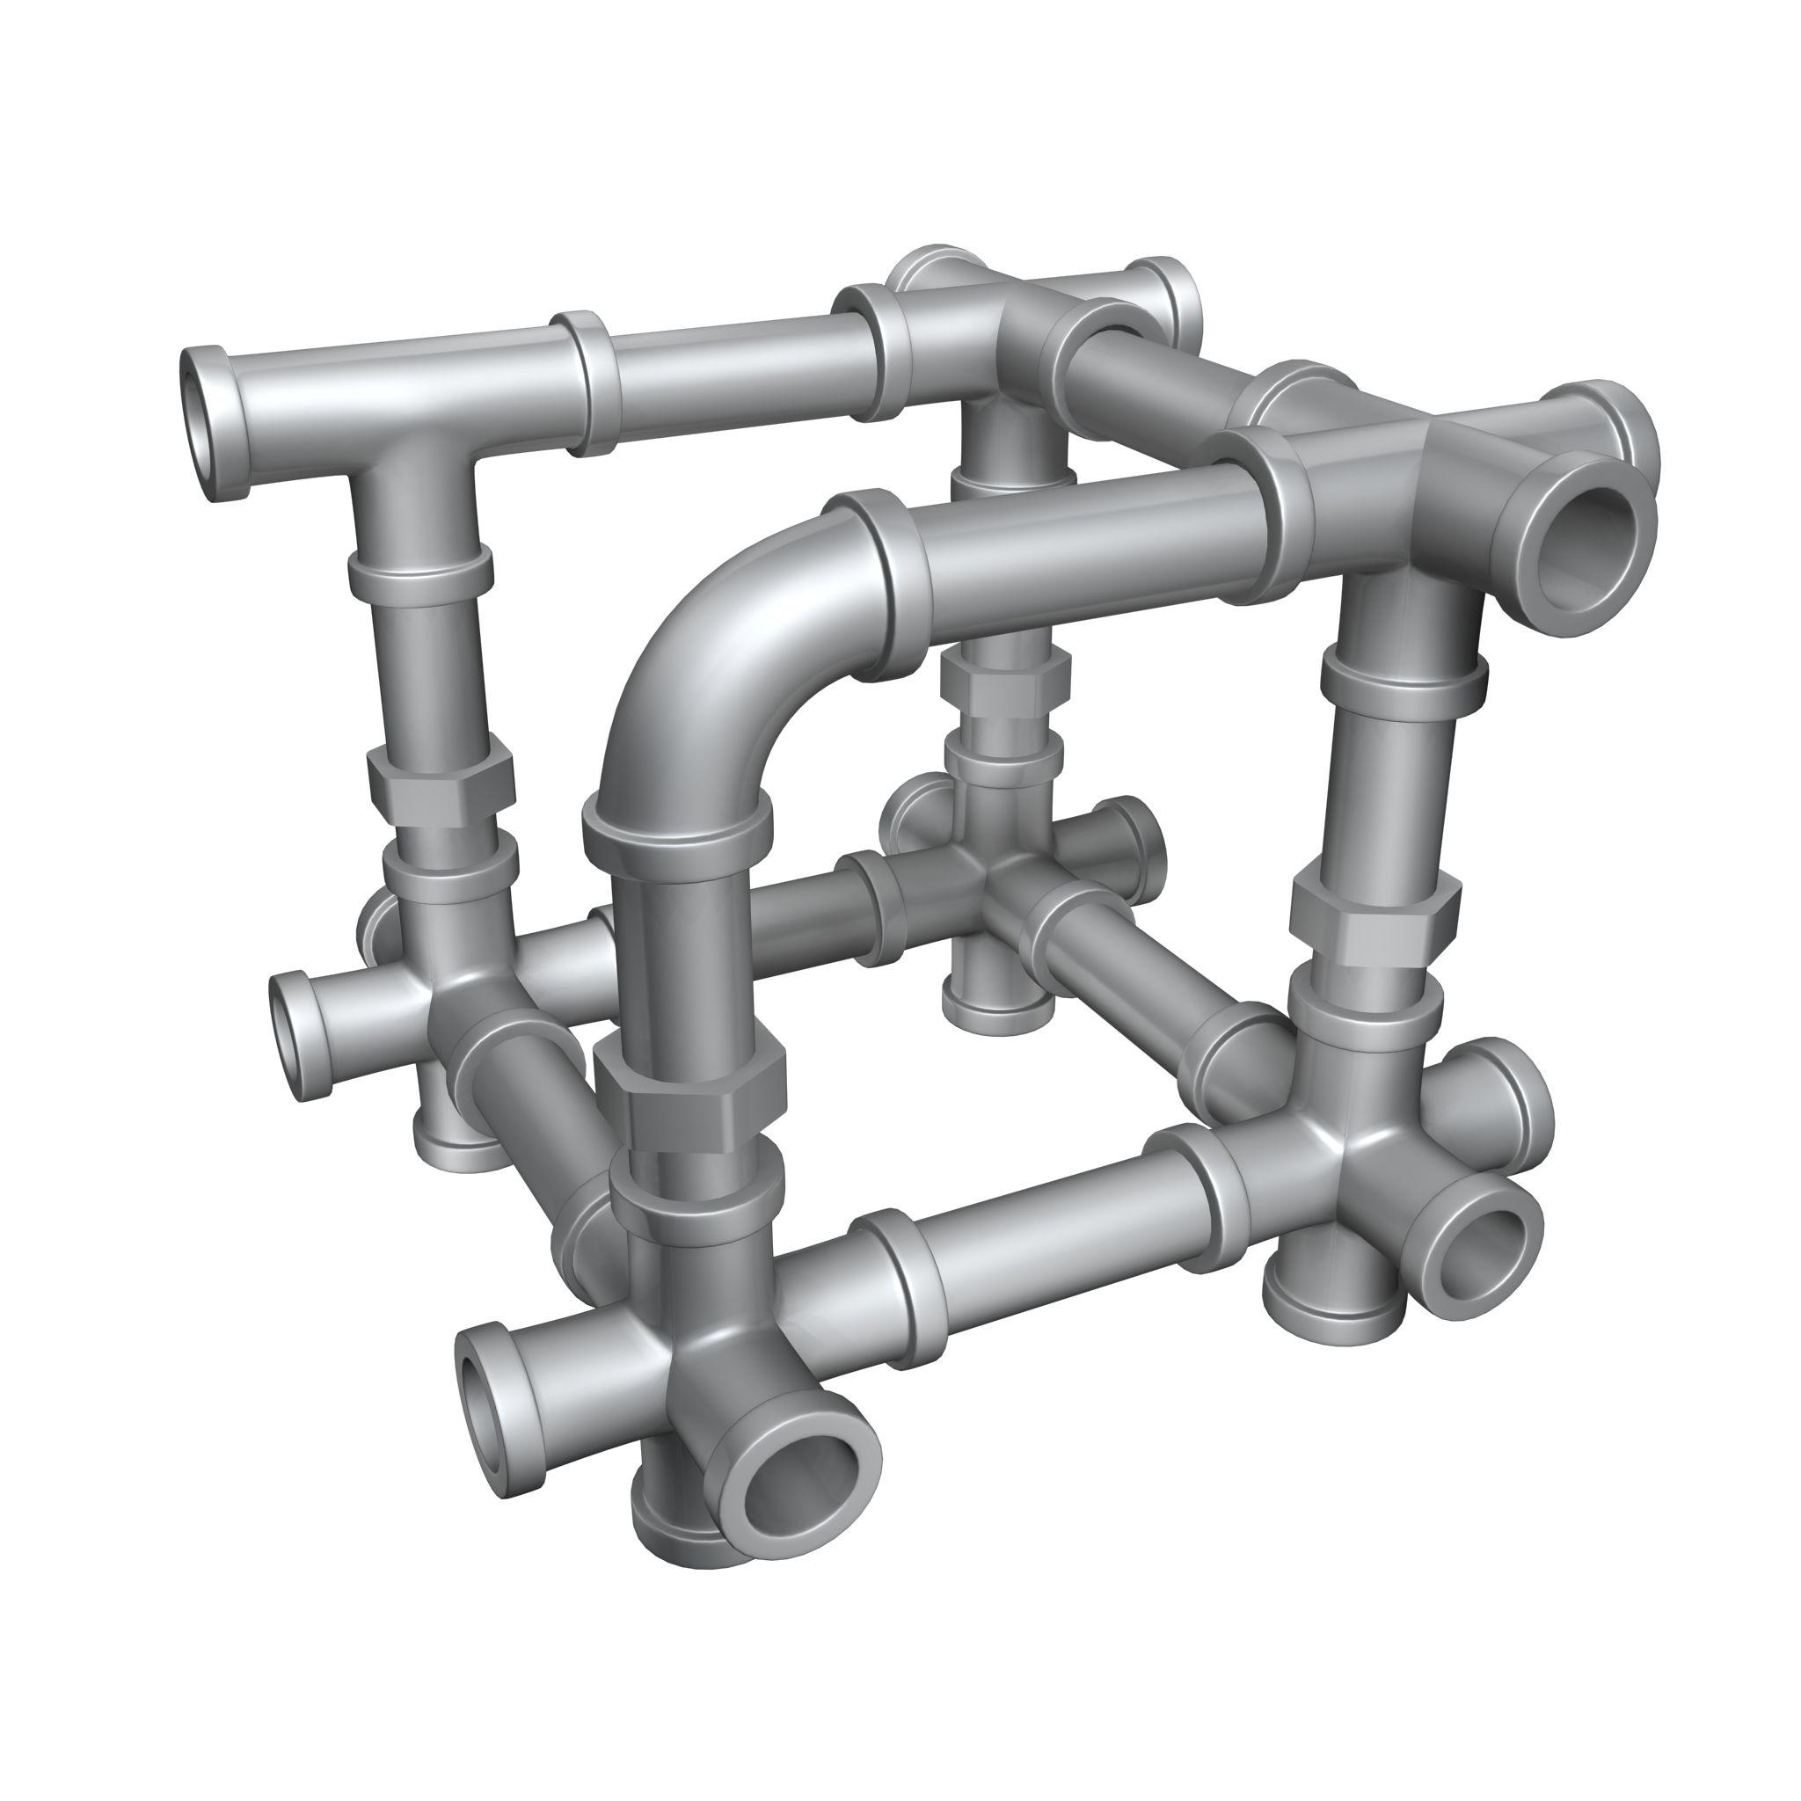
Formed by joining multiple hollow cylinders or arranging cylindrical components around an empty internal region.
Types include:
- Coaxial Hollow Cylinder Arrangement.
- Stacked Hollow Cylinder Arrangement.
- Parallel Hollow Cylinder Arrangement.
- Hollow Cylindrical Frame.
- Multi-Layer Hollow Cylinder Arrangement.
- Nested Hollow Cylinder Arrangement.

Symmetrical Cylinder-Based Composite Solids
# Source: AI Source: Provided by: [Data Path: Persons Table -> ID Column: 1, Name_En Column: Motasem Essam] -> From: [ChatGPT] on [7/25/2026]
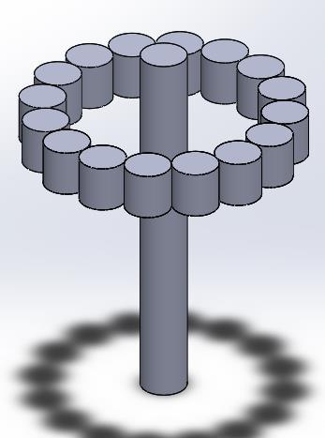
Formed by arranging cylinders so that the overall structure has one or more symmetry properties.
Types include:
- Axially Symmetrical Arrangement.
- Rotationally Symmetrical Arrangement.
- Reflection-Symmetrical Arrangement.
- Radially Symmetrical Arrangement.
- Centrally Balanced Arrangement.

Irregular Cylinder-Based Composite Solids
# Source: AI Source: Provided by: [Data Path: Persons Table -> ID Column: 1, Name_En Column: Motasem Essam] -> From: [ChatGPT] on [7/25/2026]
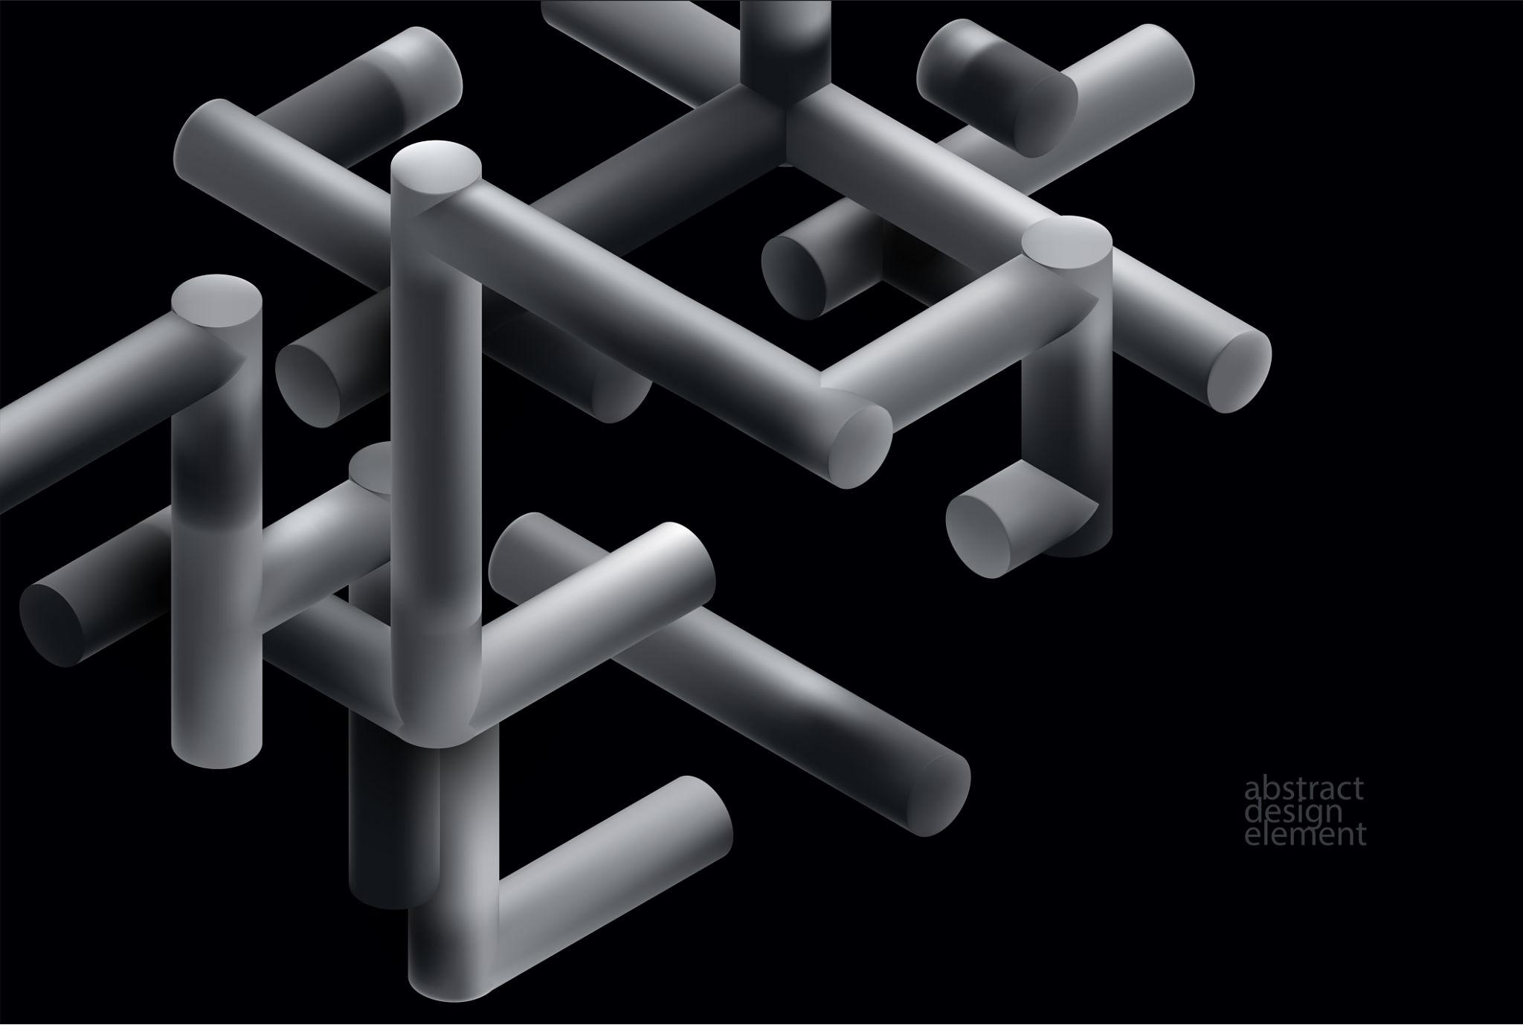
Formed by joining cylinders in a non-uniform arrangement without a regular overall pattern.
Types include:
- Random Cylinder Arrangement.
- Uneven Multi-Level Arrangement.
- Asymmetrical Arrangement.
- Mixed-Dimension Arrangement.
- Complex Intersecting Arrangement.

Classification by Cylinder Arrangement
# Source: AI Source: Provided by: [Data Path: Persons Table -> ID Column: 1, Name_En Column: Motasem Essam] -> From: [ChatGPT] on [7/25/2026]
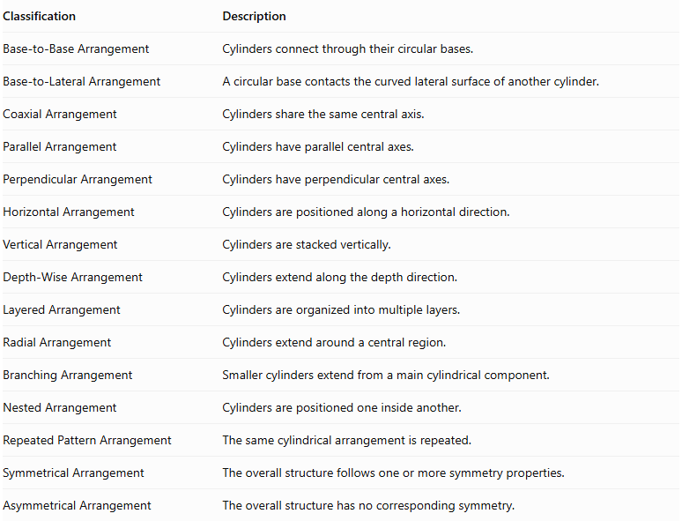
Classification | Description
Base-to-Base Arrangement | Cylinders connect through their circular bases.
Base-to-Lateral Arrangement | A circular base contacts the curved lateral surface of another cylinder.
Coaxial Arrangement | Cylinders share the same central axis.
Parallel Arrangement | Cylinders have parallel central axes.
Perpendicular Arrangement | Cylinders have perpendicular central axes.
Horizontal Arrangement | Cylinders are positioned along a horizontal direction.
Vertical Arrangement | Cylinders are stacked vertically.
Depth-Wise Arrangement | Cylinders extend along the depth direction.
Layered Arrangement | Cylinders are organized into multiple layers.
Radial Arrangement | Cylinders extend around a central region.
Branching Arrangement | Smaller cylinders extend from a main cylindrical component.
Nested Arrangement | Cylinders are positioned one inside another.
Repeated Pattern Arrangement | The same cylindrical arrangement is repeated.
Symmetrical Arrangement | The overall structure follows one or more symmetry properties.
Asymmetrical Arrangement | The overall structure has no corresponding symmetry.

Classification by Number and Dimensions of Cylinders
# Source: AI Source: Provided by: [Data Path: Persons Table -> ID Column: 1, Name_En Column: Motasem Essam] -> From: [ChatGPT] on [7/25/2026]
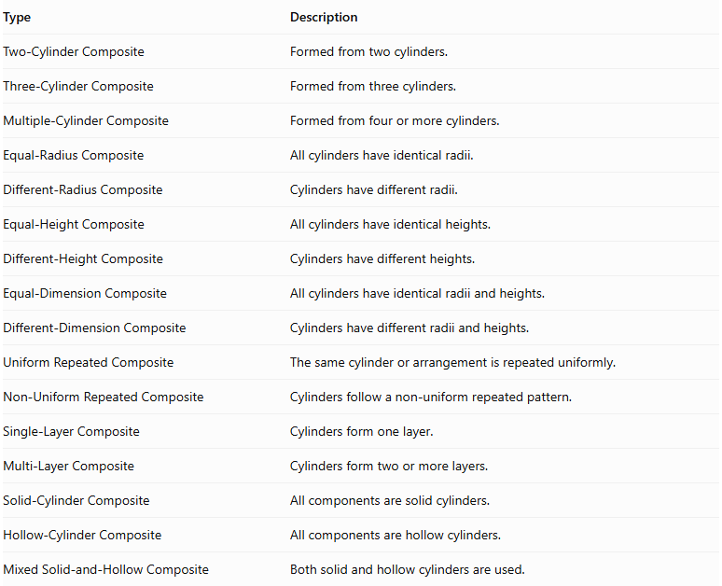
Type | Description
Two-Cylinder Composite | Formed from two cylinders.
Three-Cylinder Composite | Formed from three cylinders.
Multiple-Cylinder Composite | Formed from four or more cylinders.
Equal-Radius Composite | All cylinders have identical radii.
Different-Radius Composite | Cylinders have different radii.
Equal-Height Composite | All cylinders have identical heights.
Different-Height Composite | Cylinders have different heights.
Equal-Dimension Composite | All cylinders have identical radii and heights.
Different-Dimension Composite | Cylinders have different radii and heights.
Uniform Repeated Composite | The same cylinder or arrangement is repeated uniformly.
Non-Uniform Repeated Composite | Cylinders follow a non-uniform repeated pattern.
Single-Layer Composite | Cylinders form one layer.
Multi-Layer Composite | Cylinders form two or more layers.
Solid-Cylinder Composite | All components are solid cylinders.
Hollow-Cylinder Composite | All components are hollow cylinders.
Mixed Solid-and-Hollow Composite | Both solid and hollow cylinders are used.

Mathematical Properties and Formulas

Volume of One Cylinder
# Source: AI Source: Provided by: [Data Path: Persons Table -> ID Column: 1, Name_En Column: Motasem Essam] -> From: [ChatGPT] on [7/25/2026]
The volume of a cylinder is:
$$\boxed{V_{cylinder}=πr^{2}h}$$
Where:
- $r$ = radius of the circular base.
- $h$ = perpendicular height of the cylinder.
- $π≈3.14159$.

Total Volume of Equal Cylinders
# Source: AI Source: Provided by: [Data Path: Persons Table -> ID Column: 1, Name_En Column: Motasem Essam] -> From: [ChatGPT] on [7/25/2026]
For $n$ identical cylinders:
$$\boxed{V_{total}=nπr^{2}h}$$
Where:
- $n$ = number of cylinders.
- $r$ = radius of each cylinder.
- $h$ = height of each cylinder.

Total Volume of Different Cylinders
# Source: AI Source: Provided by: [Data Path: Persons Table -> ID Column: 1, Name_En Column: Motasem Essam] -> From: [ChatGPT] on [7/25/2026]
When cylinders have different dimensions:
$$\boxed{V_{total}=\sum_{i=1}^{n}{π}r_{i}^{2}h_{i}}$$
This formula assumes that the cylinder interiors do not overlap. If components intersect, the overlapping volume must be counted only once.

Surface Area of One Cylinder
# Source: AI Source: Provided by: [Data Path: Persons Table -> ID Column: 1, Name_En Column: Motasem Essam] -> From: [ChatGPT] on [7/25/2026]
The curved surface area is:
$$CSA=2πrh$$
The area of the two circular bases is:
$$A_{bases}=2πr^{2}$$
The total surface area is:
$$\boxed{SA=2πr^{2}+2πrh}$$

Surface Area of Repeated Cylinders
# Source: AI Source: Provided by: [Data Path: Persons Table -> ID Column: 1, Name_En Column: Motasem Essam] -> From: [ChatGPT] on [7/25/2026]
For $n$ separate identical cylinders:
$${SA}_{separate}=n(2πr^{2}+2πrh)$$
When cylinders are joined through complete matching circular bases, those joining bases become hidden.
For $m$ complete base-to-base connections:
$$\boxed{{SA}_{total}=n(2πr^{2}+2πrh)-2mπr^{2}}$$
This formula applies when all cylinders have the same radius and each connection hides two complete circular bases.
For cylinders with different radii, subtract twice the area of each actual shared circular interface:
$$\boxed{{SA}_{total}=\sum{{SA}_{i}}-2\sum{A_{shared}}}$$
This assumes complete planar contact without other intersections.

Special Formula for a Coaxial Cylindrical Stack
# Source: AI Source: Provided by: [Data Path: Persons Table -> ID Column: 1, Name_En Column: Motasem Essam] -> From: [ChatGPT] on [7/25/2026]
For $n$ cylinders with the same radius $r$, stacked coaxially with complete matching bases:
$$V_{total}=πr^{2}\sum_{i=1}^{n}{h_{i}}$$
The external surface area is:
$$\boxed{SA=2πr^{2}+2πr\sum_{i=1}^{n}{h_{i}}}$$
The two circular ends remain exposed, while the intermediate joining bases are hidden.

Hollow Cylinder Formulas
# Source: AI Source: Provided by: [Data Path: Persons Table -> ID Column: 1, Name_En Column: Motasem Essam] -> From: [ChatGPT] on [7/25/2026]
For a hollow cylinder with outer radius $R$, inner radius $r$, and height $h$:
Volume:
$$\boxed{V=πh(R^{2}-r^{2})}$$
Total surface area, including the inner curved wall and both annular ends:
$$\boxed{SA=2πh(R+r)+2π(R^{2}-r^{2})}$$
For a composite structure containing hollow cylinders, only the exposed surfaces should be counted.

Worked Examples

Example 1: Equal-Radius Coaxial Cylinder-Based Composite Solid
# Source: AI Source: Provided by: [Data Path: Persons Table -> ID Column: 1, Name_En Column: Motasem Essam] -> From: [ChatGPT] on [7/25/2026]
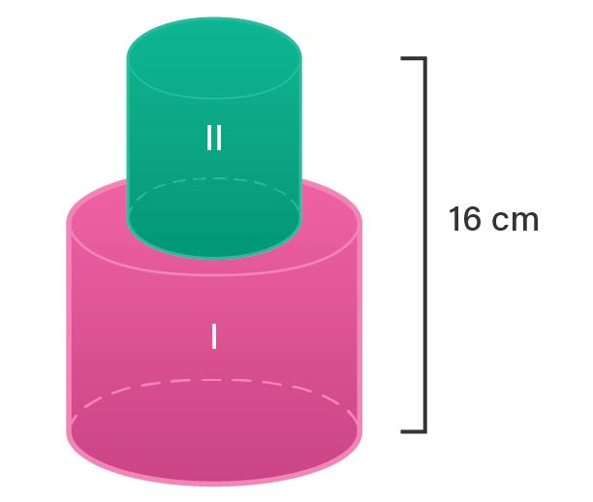
Given:
- Number of cylinders: $n=2$.
- Radius of each cylinder: $r=3 cm$.
- Height of first cylinder: $h_{1}=4 cm$.
- Height of second cylinder: $h_{2}=6 cm$.
- Arrangement: vertically stacked and coaxial.
Step 1: Calculate the volume of the first cylinder.
$$V_{1}=πr^{2}h_{1}$$
$$V_{1}=π(3)^{2}(4)=36π$$
Step 2: Calculate the volume of the second cylinder.
$$V_{2}=πr^{2}h_{2}$$
$$V_{2}=π(3)^{2}(6)=54π$$
Step 3: Calculate the total volume.
$$V_{total}=V_{1}+V_{2}$$
$$=36π+54π$$
$$\boxed{V_{total}=90π≈282.74{ cm}^{3}}$$
<badge color="success">Volume = 282.74 cm³</badge>
Step 4: Calculate the surface area of each cylinder.
First cylinder:
$${SA}_{1}=2π(3)^{2}+2π(3)(4)$$
$${SA}_{1}=18π+24π=42π$$
Second cylinder:
$${SA}_{2}=2π(3)^{2}+2π(3)(6)$$
$${SA}_{2}=18π+36π=54π$$
Step 5: Remove the hidden joining faces.
There is one shared circular interface:
$$A_{shared}=π(3)^{2}=9π$$
Both joining bases are hidden, so:
$${SA}_{total}={SA}_{1}+{SA}_{2}-2A_{shared}$$
$$=42π+54π-18π$$
$$\boxed{{SA}_{total}=78π≈245.04{ cm}^{2}}$$
<badge color="success">Surface Area = 245.04 cm²</badge>
Final Result:
- Total Volume = $90π≈282.74{ cm}^{3}$.
- External Surface Area = $78π≈245.04{ cm}^{2}$.

Example 2: Different-Radius Stepped Cylinder-Based Composite Solid
# Source: AI Source: Provided by: [Data Path: Persons Table -> ID Column: 1, Name_En Column: Motasem Essam] -> From: [ChatGPT] on [7/25/2026]
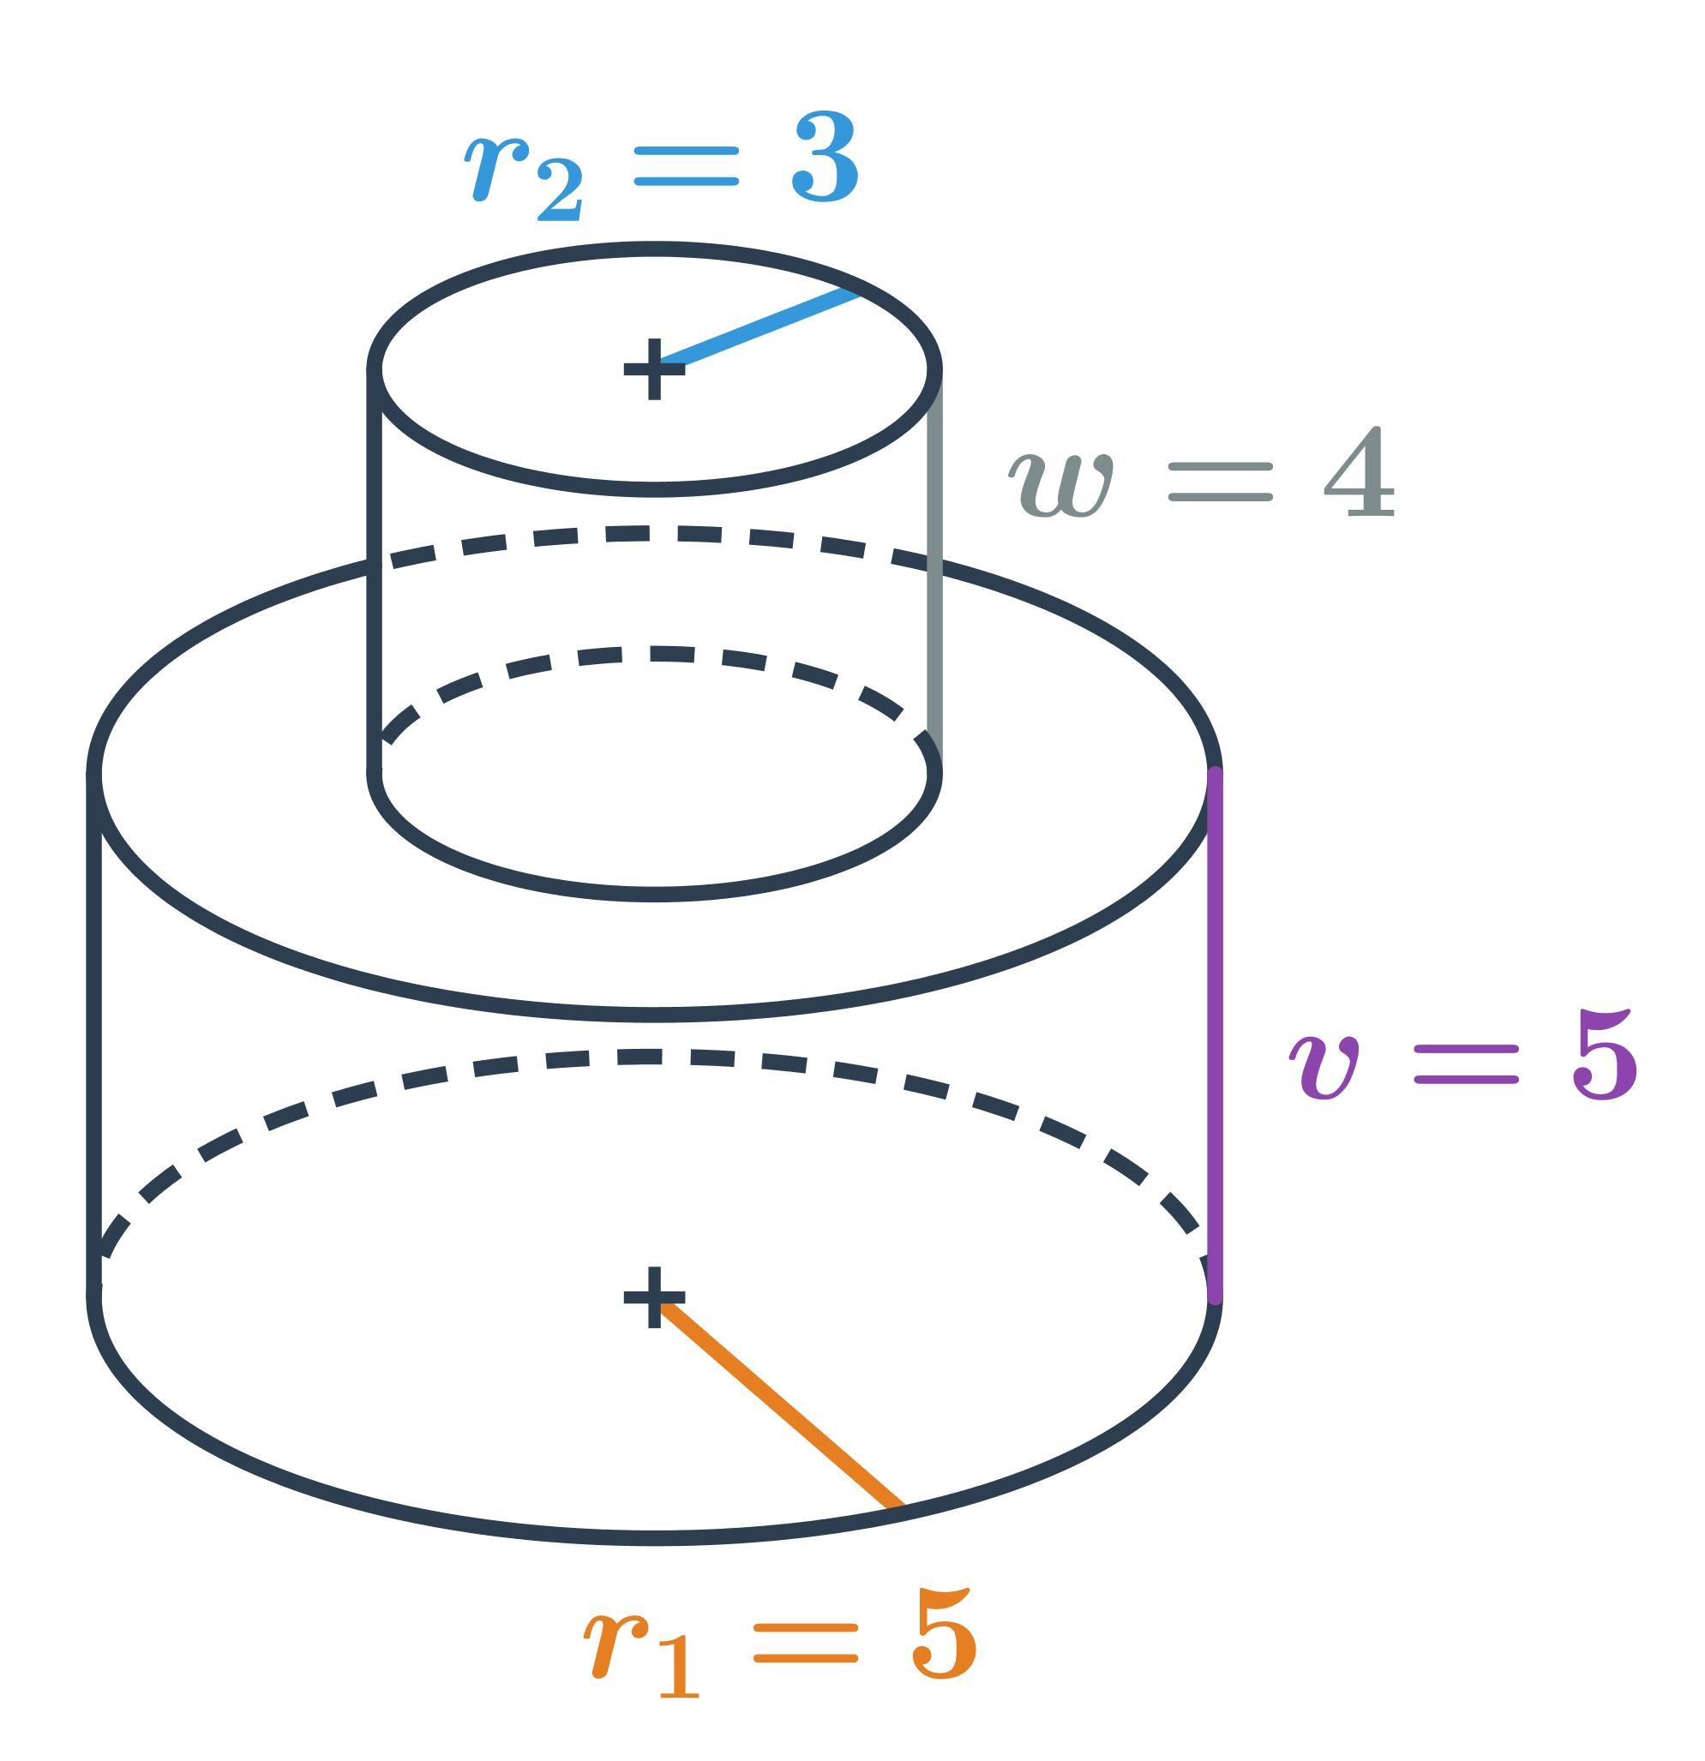
Given:
- Lower cylinder:
- Radius: $R=4 cm$.
- Height: $h_{1}=5 cm$.
- Upper cylinder:
- Radius: $r=2 cm$.
- Height: $h_{2}=3 cm$.
- Arrangement: vertically stacked and coaxial.
Step 1: Calculate the volume of the lower cylinder.
$$V_{1}=πR^{2}h_{1}$$
$$V_{1}=π(4)^{2}(5)=80π$$
Step 2: Calculate the volume of the upper cylinder.
$$V_{2}=πr^{2}h_{2}$$
$$V_{2}=π(2)^{2}(3)=12π$$
Step 3: Calculate the total volume.
$$V_{total}=80π+12π$$
$$\boxed{V_{total}=92π≈289.03{ cm}^{3}}$$
<badge color="success">Volume = 289.03 cm³</badge>
Step 4: Calculate the surface area of the lower cylinder.
$${SA}_{1}=2πR^{2}+2π{Rh}_{1}$$
$$=2π(4)^{2}+2π(4)(5)$$
$$=32π+40π=72π$$
Step 5: Calculate the surface area of the upper cylinder.
$${SA}_{2}=2πr^{2}+2π{rh}_{2}$$
$$=2π(2)^{2}+2π(2)(3)$$
$$=8π+12π=20π$$
Step 6: Calculate the hidden joining faces.
The upper cylinder joins the lower cylinder through a circular interface with radius $2 cm$.
$$A_{shared}=π(2)^{2}=4π$$
Subtract both hidden circular faces:
$${SA}_{total}={SA}_{1}+{SA}_{2}-2A_{shared}$$
$$=72π+20π-8π$$
$$\boxed{{SA}_{total}=84π≈263.89{ cm}^{2}}$$
<badge color="success">Surface Area = 263.89 cm²</badge>
Final Result:
- Total Volume = $92π≈289.03{ cm}^{3}$.
- External Surface Area = $84π≈263.89{ cm}^{2}$.
Notice that the exposed top of the lower cylinder is an annular region. Its area is the lower circular area minus the upper cylinder's joining area.

Important Characteristics
# Source: AI Source: Provided by: [Data Path: Persons Table -> ID Column: 1, Name_En Column: Motasem Essam] -> From: [ChatGPT] on [7/25/2026]
- Repeated Components: The structure contains multiple cylindrical components.
- Variable Dimensions: Cylinders may have equal or different radii and heights.
- Circular Joining Faces: Cylinders commonly connect through their circular bases.
- Curved External Surfaces: The outer boundary includes cylindrical curved surfaces.
- Flexible Configurations: Cylinders can form stacked, coaxial, radial, branching, and irregular structures.
- Hidden Surfaces: Joining bases are excluded from the external surface area.
- Additive Volume: Component volumes can be added when their interiors do not overlap.
- Axis Relationships: The cylinders may have parallel, coincident, perpendicular, or differently oriented axes.
- Symmetry Properties: The overall structure may have rotational, axial, or reflection symmetry.
- Modular Construction: Additional cylinders can extend an existing arrangement.

Comparison with Other Repeated Composite Solids
# Source: AI Source: Provided by: [Data Path: Persons Table -> ID Column: 1, Name_En Column: Motasem Essam] -> From: [ChatGPT] on [7/25/2026]
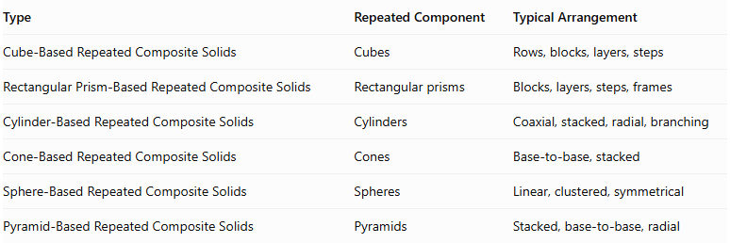
Type | Repeated Component | Typical Arrangement
Cube-Based Repeated Composite Solids | Cubes | Rows, blocks, layers, steps
Rectangular Prism-Based Repeated Composite Solids | Rectangular prisms | Blocks, layers, steps, frames
Cylinder-Based Repeated Composite Solids | Cylinders | Coaxial, stacked, radial, branching
Cone-Based Repeated Composite Solids | Cones | Base-to-base, stacked
Sphere-Based Repeated Composite Solids | Spheres | Linear, clustered, symmetrical
Pyramid-Based Repeated Composite Solids | Pyramids | Stacked, base-to-base, radial
Main distinction: Cylinder-based repeated composite solids use cylinders as their repeated building components. Their geometry is characterized by circular bases, central axes, radii, heights, and curved lateral surfaces.

Applications
# Source: AI Source: Provided by: [Data Path: Persons Table -> ID Column: 1, Name_En Column: Motasem Essam] -> From: [ChatGPT] on [7/25/2026]
- Mechanical Engineering: Designing shafts, rollers, rotating components, and cylindrical assemblies.
- Construction: Creating columns, cylindrical supports, and structural elements.
- Plumbing: Designing connected pipe systems and branching cylindrical networks.
- Manufacturing: Producing cylindrical components and repeated industrial parts.
- Automotive Engineering: Designing rollers, axles, and cylindrical mechanical assemblies.
- Architecture: Creating cylindrical columns and decorative structures.
- Mathematics Education: Teaching volume, surface area, and spatial relationships.
- Computer Graphics: Building three-dimensional models using repeated cylindrical components.
- Industrial Design: Developing modular cylindrical products and equipment.
- Game Design: Creating pipes, towers, pillars, and cylindrical structures.

Key Points
# Source: AI Source: Provided by: [Data Path: Persons Table -> ID Column: 1, Name_En Column: Motasem Essam] -> From: [ChatGPT] on [7/25/2026]
- Cylinder-based repeated composite solids consist of multiple cylinders joined into one structure.
- Their components may have equal or different radii and heights.
- They can form linear, coaxial, stacked, stepped, radial, branching, and hollow arrangements.
- The volume of one cylinder is:
$$V=πr^{2}h$$
- For $n$ identical non-overlapping cylinders:
$$V_{total}=nπr^{2}h$$
- The total surface area of one cylinder is:
$$SA=2πr^{2}+2πrh$$
- Shared circular bases must be excluded from the external surface area.
- Side-by-side or intersecting cylinders may require more advanced geometric calculations because their contact regions are not necessarily complete planar faces.

Conclusion
# Source: AI Source: Provided by: [Data Path: Persons Table -> ID Column: 1, Name_En Column: Motasem Essam] -> From: [ChatGPT] on [7/25/2026]
Cylinder-Based Repeated Composite Solids are three-dimensional structures formed by joining multiple cylinders in repeated arrangements. They include linear structures, coaxial stacks, stepped cylinders, radial arrangements, branching structures, hollow configurations, and irregular assemblies.
Their mathematical properties are based on cylindrical volume, circular base areas, curved lateral surfaces, and the relationships between their central axes.
They provide a foundation for understanding more complex repeated composite solids and cylindrical structures used in engineering, construction, manufacturing, and geometric modeling.

